How to Write Markdown  files!

Let’s do that…

 Firstly , the _file extension_  should be  ** md ** ☺

Are you wondering file extension became italic and md as bold!

Let mHow to Write Markdown  files!

Let’s do that…

 Firstly , the _file extension_  should be  ** md ** ☺

Are you wondering file extension became italic and md as bold!

Let me tell you its secret…☺

Haha , it’s the syntax…

Okay, let’s together learn how to write  **  markdown files  **

Headings

For adding headings in markdown files, mark down support 6 levels of formatting from level1 to level 6.

# for level 1, ## level22, ### level 3 and so on.. up to 6.

Note: there should be space before the header Text.

Italic

For doing text in italic format underscore followed by text in between and underscore i.e

( _sometext_ )

Bold

For doing text in bold format , you can surround words with two asterisks ( ** ) before and after the word.

** bolded text **

You can do both italic and bold at the same time☺

_** text **_ or **_ text_**

Links

There are two different link types in Markdown, but both of them render the exact same way.

1.inline link : link text in brackets ( ) and link in square brackets [ ]

e.g: 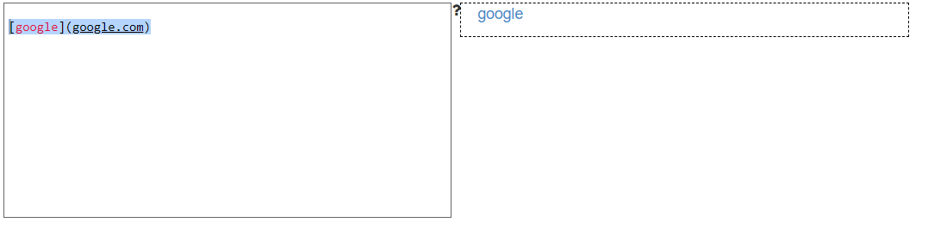2.reference link: link text in first square brackets [ ] and reference in another square brackets [ ],

The reference should be assigned with an link.

e.g: 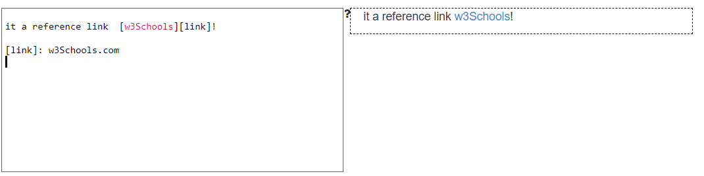

Images

The syntax is similar to link, except exclamation at the beginning

![alt](<https://www.pexels.com/photo/scenic-view-of-beach-248797/>)

Blockquote

To create a block quote, all you have to do is preface a line with the "greater than" caret (>). For example:

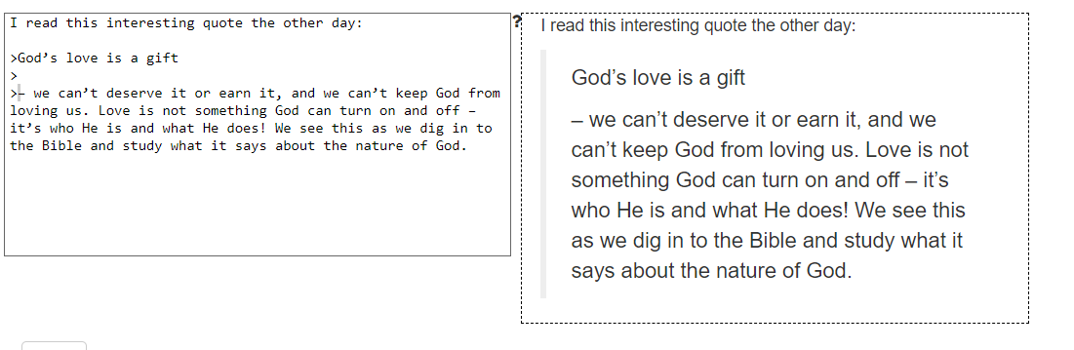

Lists

creating lists in Markdown

* To create an unordered list, you'll want to preface each item in the list with an asterisk ( * )
* An ordered list is prefaced with numbers

Example: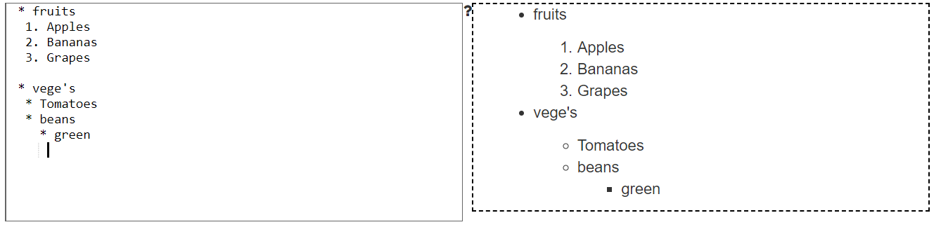

Paragraphs